Session 2026-2027

Vision:Dream of where you want. | Mission: Means to achieve Vision

Program Educational Objectives of the program (PEO): (broad statements that describe the professional and career accomplishments)
PEO1 | Preparation | P: Preparation | Pep-CL abbreviation  pronounce as Pep-si-lL easy to recall
PEO2 | Core Competence | E: Environment (Learning Environment) | Pep-CL abbreviation  pronounce as Pep-si-lL easy to recall
PEO3 | Breadth | P: Professionalism | Pep-CL abbreviation  pronounce as Pep-si-lL easy to recall
PEO4 | Professionalism | C: Core Competence | Pep-CL abbreviation  pronounce as Pep-si-lL easy to recall
PEO5 | Learning Environment | L: Breadth (Learning in diverse areas) | Pep-CL abbreviation  pronounce as Pep-si-lL easy to recall

Program Outcomes (PO): (statements that describe what a student should be able to do and know by the end of a program)
Keywords of POs:
Engineering knowledge,Problem analysis, Design/development of solutions,Conduct Investigations of Complex Problems, Engineering Tool Usage, The Engineer and The World,Ethics, Individual and Collaborative Team work,Communication, Project Management and Finance, Life-Long Learning

PSO Keywords: Cutting edge technologies, Research

“I am an engineer, and I know how to apply engineering knowledge to investigate, analyse and design solutions to complex problems using tools for entire world following all ethics in a collaborative way with proper management skills throughout my life.” to contribute to the development of cutting-edge technologies and Research.

Integrity: I will adhere to the Laboratory Code of Conduct and ethics in its entirety.

Name and Signature of Student and Date
(Signature and Date in Handwritten)

Session | 2026-27 (ODD) |  | Course Name | Web Technology Lab
Semester | 3 |  | Course Code | 23CT1301
Roll No | 65 |  | Name of Student | Shubham Dnyaneshwar Umredkar
Practical Number |  | 4B
Course Outcome |  | - Understand various internet technologies.  - Design the web pages using HTML and CSS.  - Implement the XML technology to store the data.  - Develop the interactive web pages using JavaScript.
Aim |  | JavaScript — DOM Manipulation
Problem Definition |  | Build a To-Do List web app where users can add, delete, and mark tasks as complete, using vanilla JavaScript DOM methods only.
Theory  (100 words) |  | JavaScript DOM Manipulation is used to access and modify HTML elements dynamically. DOM stands for Document Object Model. It represents the web page as a collection of objects that JavaScript can control. Using DOM methods such as getElementById(), createElement(), appendChild(), and remove(), we can add, change, or delete elements from a webpage. In a To-Do List application, DOM manipulation is used to create new tasks, mark tasks as completed, and remove tasks. Event handling is also used to perform actions when the user clicks buttons. Thus, DOM manipulation makes webpages interactive and responsive.
Procedure and Execution  (100 Words) |  | Step for Implementation:  - Create an HTML page with a heading for the To-Do List.  - Add an input box where the user can enter a task.  - Add an Add Task button.  - Create an empty list using the <ul> element.  - Use getElementById() to access the input box and list.  - Use createElement() to create a new task.  - Add Complete and Delete buttons for every task.  - Use appendChild() to add tasks to the list.  - Use JavaScript events to mark tasks as completed.  - Use the remove() method to delete tasks.
Code:
<!DOCTYPE html>
<html lang="en">

<head>
<meta charset="UTF-8">
<title>To-Do List</title>

<style>
body {
font-family: Arial;
text-align: center;
}

input {
padding: 8px;
}

button {
padding: 8px;
margin: 5px;
}

li {
margin: 10px;
}

.completed {
text-decoration: line-through;
}
</style>
</head>

<body>

<h2>To-Do List</h2>

<input type="text" id="taskInput" placeholder="Enter a task">

<button onclick="addTask()">Add Task</button>

<ul id="taskList"></ul>

<script>

function addTask() {

let input = document.getElementById("taskInput");
let task = input.value.trim();

if (task == "") {
alert("Please enter a task.");
return;
}

let li = document.createElement("li");

let taskText = document.createElement("span");
taskText.innerHTML = task;

let completeButton = document.createElement("button");
completeButton.innerHTML = "Complete";

completeButton.onclick = function() {
taskText.classList.toggle("completed");
};

let deleteButton = document.createElement("button");
deleteButton.innerHTML = "Delete";

deleteButton.onclick = function() {
li.remove();
};

li.appendChild(taskText);
li.appendChild(completeButton);
li.appendChild(deleteButton);

document.getElementById("taskList").appendChild(li);

// Clear input box
input.value = "";
}

</script>

</body>

</html>

Output:
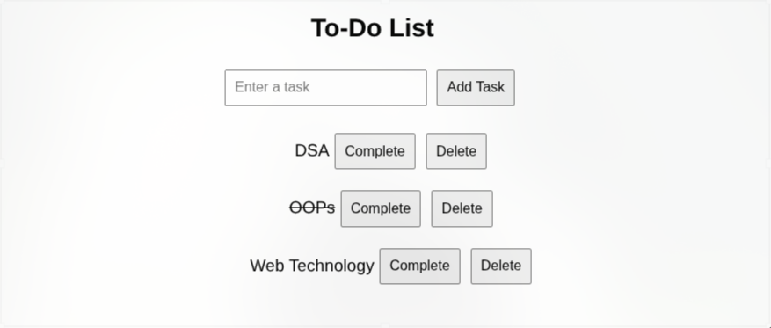
Output Analysis |  | The output displays a simple To-Do List application with an input field and an Add Task button. The user can enter a task and click the button to add it to the list. Every task contains Complete and Delete buttons. When the Complete button is clicked, a line appears through the task, indicating that the task has been completed. When the Delete button is clicked, the selected task is removed from the list. If the user tries to add an empty task, an alert message is displayed. Thus, JavaScript DOM methods dynamically control the webpage.
Link of student Github profile where lab assignment has been uploaded |  | https://github.com/shubham07-codes/Web-Technology-Lab
Conclusion |  | This practical helped us understand JavaScript DOM manipulation and event handling. We learned how to access HTML elements and dynamically create, modify, and remove elements using JavaScript. Methods such as getElementById(), createElement(), appendChild(), remove(), and classList.toggle() were used in the To-Do List application. The application allows users to add new tasks, mark completed tasks, and delete unnecessary tasks without refreshing the webpage. Therefore, DOM manipulation is an important feature of JavaScript that helps developers create interactive and dynamic web applications.
Plag Report (Similarity index < 12%)
Date |  | 14-09-2026

